qgSurf
Determination of intersections between Cartesian planes and raster digital elevation models
Algorithm Theoretical Basis Document

Vers. 1.0
Last editing: 2018-11-25
Completed: No

To solve the plane-DEM intersection problem, it is converted from its original 3D nature, to a simplified 2D approach.
The basic concept is to determine the intersection between lines in the raster i direction, and also in the raster j direction, and at the end simply combining the two results into a single solution, with the same dimensionality (i.e., points).
This approach is a generalization of the approach formerly used in qgSurf (and by extension in gsf) that was more restricted and assumed no grid rotation/skewing.
However, the theoretical affine transformation matrix used in the GDAL geotransform allows both rotation and skewing (Fig. 1), so that a more general approach is required to correctly handle all the cases, also those that are rare in the practice.

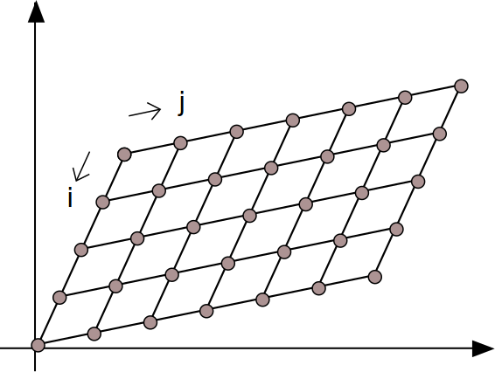
Illustration 1: Example of grid with applied affine transformation.

